Requirements Specification
for
Library Management System

January 2024
Version 0.1

Prepared by Akshat Jain
Manit Bhopal
17 January 2004

Change History

Date | Version | Description | Updated By
17 Jan 2024 | 0.1 | Initial Draft

Document Approvals

Name | Role | Signature

Table of Contents

1 Introduction 4
1.1 Purpose 4
1.2 Document Conventions 4
1.3 Project Scope 4
1.4 References 4
2 System Description 4
3 Functional Requirements 4
3.1 System Features 4
3.1.1 System Feature 1 5
3.1.2 System Feature 2 5
3.2 Use Cases 5
3.2.1 Use Case Diagrams 5
3.2.2 Use Case 1 5
3.2.3 Use Case 2 5
3.3 Entity Relationship Diagrams 5
3.4 Data Dictionary 6
3.4.1 Entity 1 6
3.4.2 Entity 2 6
4 External Interface Requirements 6
5 Technical Requirements (Non functional) 6
5.1 Performance 6
5.2 Scalability 6
5.3 Security 6
5.4 Maintainability 6
5.5 Usability 6
5.6 Multi lingual Support 6
5.7 Auditing and Logging 6
5.8 Availability 6
6 Open Issues 7

Introduction

Purpose
The purpose of the Software Requirements Specification (SRS) for a Library Management System is to clearly define and document the functional and non-functional requirements, providing a shared understanding among stakeholders and serving as a guide for development, testing, and project management.

Document Conventions
<Indicate any special document conventions used including notation or approaches used for requirements capture. For example, you can specify that Crow's notation is used for ER diagrams.>

Project Scope
The system will include the following core features:

- Member management: Register new members, manage member accounts, and track borrowing history.
- Resource management: Catalog books, journals, and other library resources, including adding, editing, and searching.
- Circulation management: Borrow and return resources, manage due dates, and generate fines and alerts.
- Search and discovery: Enable users to search the library catalog by title, author, subject, and other criteria.
- Online account management: Allow users to view their borrowing history, renew resources, and update their account information.
- Reporting and analytics: Generate reports on resource usage, borrowing trends, and member activity.

References
<This should contain links to all external documents and web resources referred in the requirements. Sometimes prototypes or product vision are specified in a separate document. Link them here. Also ensure that you link to the correct version.>

System Description
<This section can contain a detailed overview of the software system being built. It can contain a subsection detailing the existing system followed by the proposed system details. If relevent, this section can also contain business details such as organizational hierarchy. Basically provide everything that is necessary to understand the Fuctional Requirements section which follows this.>

Functional Requirements
<This section contains system requirements followed by various requirement models which can be used for detailed design. In addition to the following sections, you can also add process flow diagrams, data flow diagrams, flowcharts and decision tables if required.>

System Features
<This section specifies the high level system features required in the software product. Each requirement given below has a unique tag that can be referred in the traceability matrix.>

System Feature 1
Description:
Input:
Processing:
Output:

System Feature 2

Use Cases

Use Case Diagrams
<One or more diagrams depicting how various actors interact with the software system.>

Use Case 1
<This provides a detailed description of the use case. Usually it is captured in the following table format. Add more rows or removing rows depending on your specific requirement.>
ID | <unique use case id>
Description | <Detailed description of the use case>
Actors | <Specify various actors who will invoke this use case>
Preconditions | <An example for a purchase item use case would be - user must be logged in to invoke purchase item.>
Basic Steps | <Usual flow of the use case indicating the various steps in it>
Alternate Steps
Exceptions | <Exceptions indicate what should happen if a rare unexpected condition occurs. For example, if the use case is purchase item, what happens when the the stock runs out during purchase?>
Business validations/Rules | <If business rules are already specified in the system features section, provide a link. Otherwise specify the rules.>
Postconditions

Use Case 2

Entity Relationship Diagrams
<One or diagrams to depict all the entities in the system and their relationships. You can use different notations for ER diagrams. Following is a very simple ER diagram in Crow's notation.>
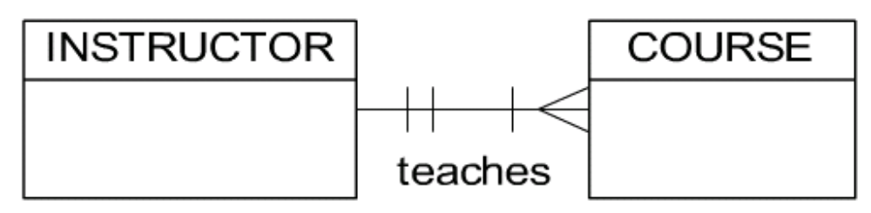

Data Dictionary

Entity 1
<A brief description of the entity followed by a table containing all its attributes as shown below. >
Attribute | Type | Optional? | Notes
<Attribute Name> | <Data type of the attribute> | <Y or N> | <Explain any specific restrictions or rules applcable on this attribute>

Entity 2

External Interface Requirements
<Provide sub sections for each external interface. Identify all the input and ouput from the external interfaces.>

Technical Requirements (Non functional)
<Please note that all the following subsections may not be applicable for a system. Sometimes you will have to add additional sections (for example, Legal requirements)>

Performance
<For example, What is the response time required?>

Scalability
<For example, how many users the system should support after two years of operation?>

Security
<For example, is data encryption required?>

Maintainability

Usability

Multi lingual Support
<What are the languages that software system should support?>

Auditing and Logging

Availability
<For example, Is any kind of downtime acceptable or required?>

Open Issues
<There could be open issues even at the end of the requirements elicitation. List of all of them here so it can be tracked and closed later. Some of these issues may later become project risks as well.>

